Canvas Outcomes -

Aligning Program Level Outcomes to Canvas Assignments

Step-by-Step Guide for Instructors
In order to run outcome reports at the program level in Canvas, it is necessary to create Canvas assignments (or Discussions), attach rubrics with program level outcomes, and use the rubrics to score student work. It is not necessary for students to submit anything to an assignment in order to use the rubric. If students are not expected to submit to a Canvas assignment, you may create a no submission assignment, attach the rubric, and score it as described below. For more on Outcomes, see Canvas Outcomes-Aligning Program Level Outcomes in Course Level Quizzes.

- Import program level outcomes to a course (skip this step if you already imported program level outcomes to the course)
- Create a rubric with program level outcomes for a particular assignment
- Add the rubric to an assignment
- Use the rubric to score the assignment

I. Import program level outcomes to a course
- Go to the desired course.
- Click Outcomes in the course navigation menu.
- Click Find*.
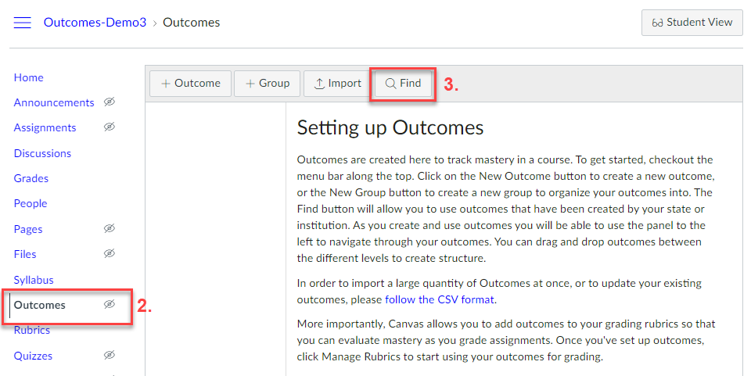
*This guide is based on outcomes already added at the program level by an administrator. If you click on Find and then Account Standards as shown below and don’t see an outcome folder with your program listed (e.g., [Science]COMPUTER SCIENCE), please contact your program chair. Do not use the +Outcome or Import button to add outcomes to your course.
4. Click Account Standards.
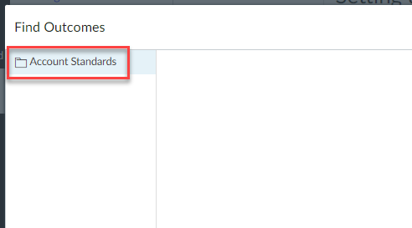
5. Click the program level folder.
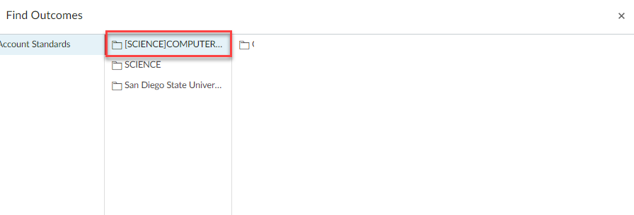

6. Click the program level student learning outcomes folder.
7. Click on a relevant outcome and click Import.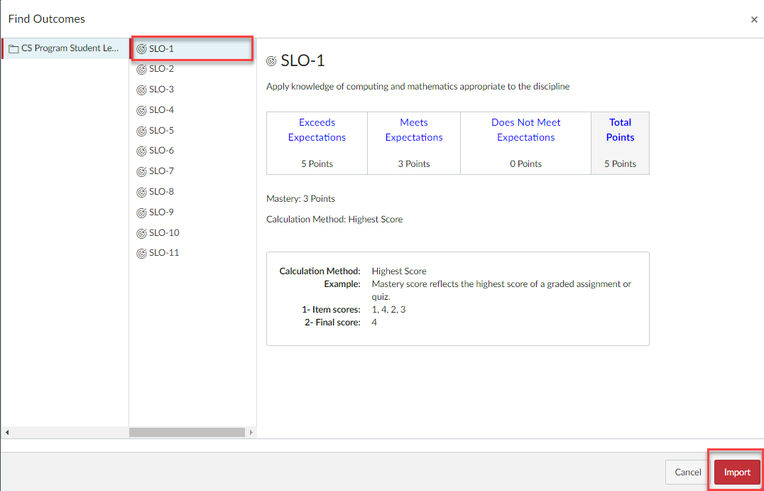
8. Repeat steps 3-7 to find and import each outcome mapped to your course. Next, you will create a rubric with only the outcome(s) specific to a particular assignment in the course.

II. Create a rubric with program level outcomes for a particular assignment
- Go to the desired course.
- Click Rubrics in the course navigation menu.
- Click +Add Rubric.
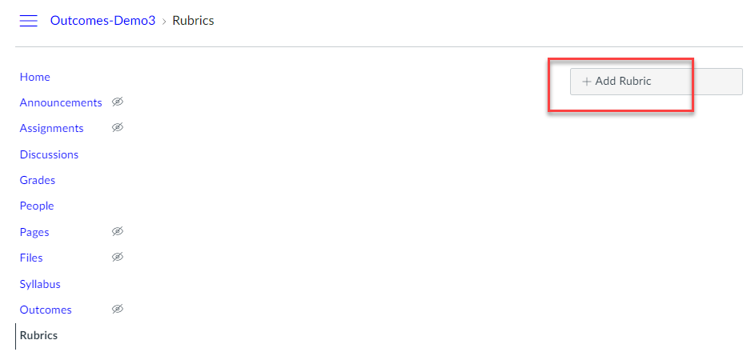

4. Give the rubric a Title specific to the assignment.
5. Click Find Outcome.
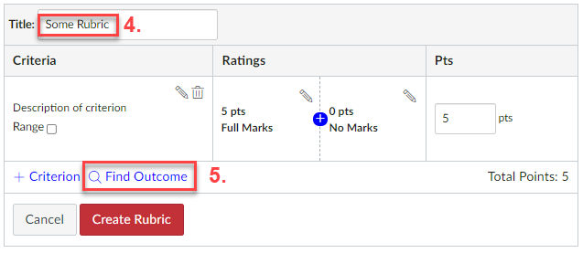

6. Click to select the desired outcome.
7. Choose whether you wish to “Use this criterion for scoring” (i.e., if you want the points in the outcome to count towards student grades, click to select the option. Otherwise, leave it deselected.)
8. Click Import.
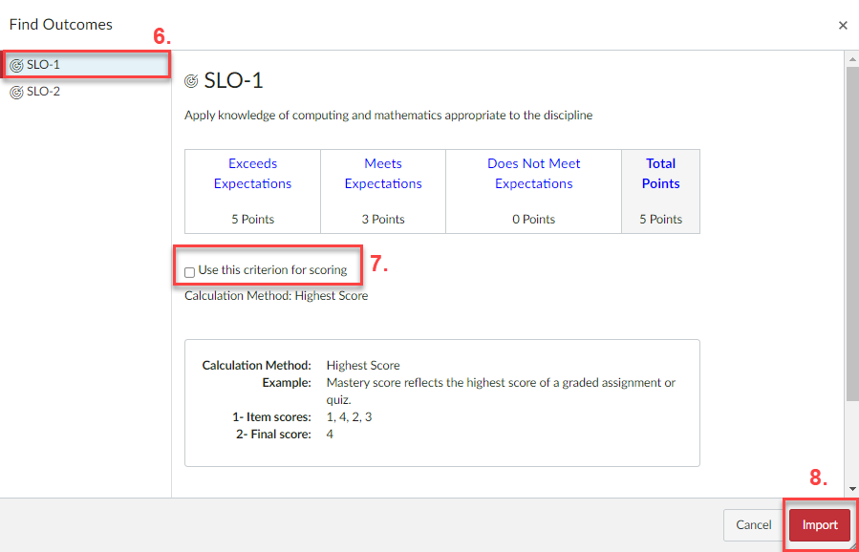
9. Repeat steps 5-8 to find and import any other outcome(s) relevant to the assignment.

10. Edit or remove the default criterion using the pencil or trash icon.
11. Add any course-specific criteria using the +Criterion button.
12. Click Create Rubric. Upon adding the rubric to an assignment, you will have an opportunity to set additional options.
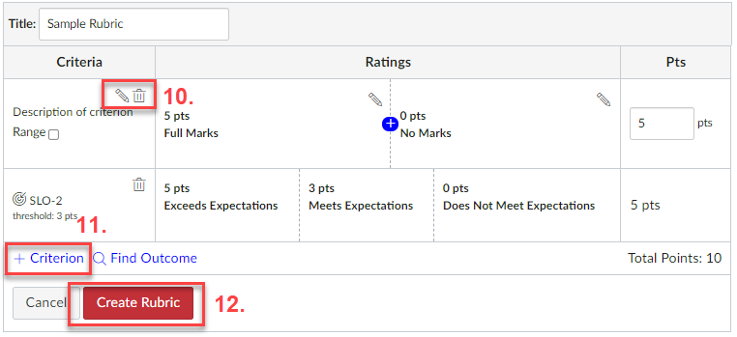

III. Add the rubric to an assignment
- In the desired course, go to Assignments or Modules.
- Create a Canvas Assignment or go to an existing one.
- After saving the new assignment or clicking the link to the existing one, click the +Rubric button.
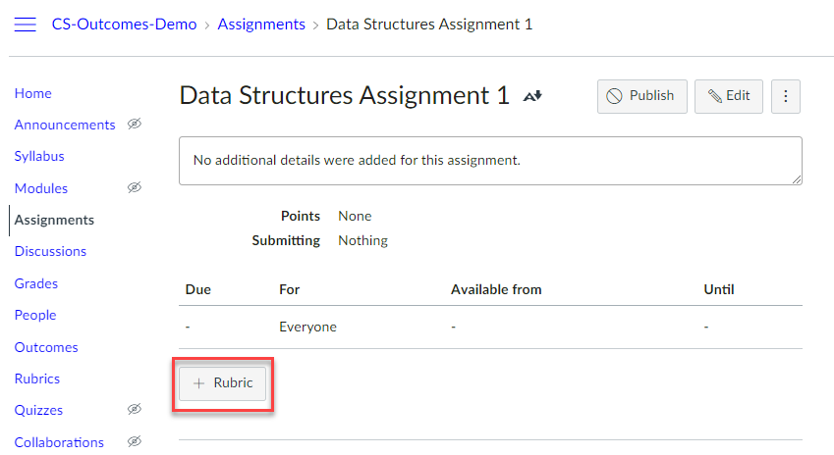

- Click Find a Rubric.
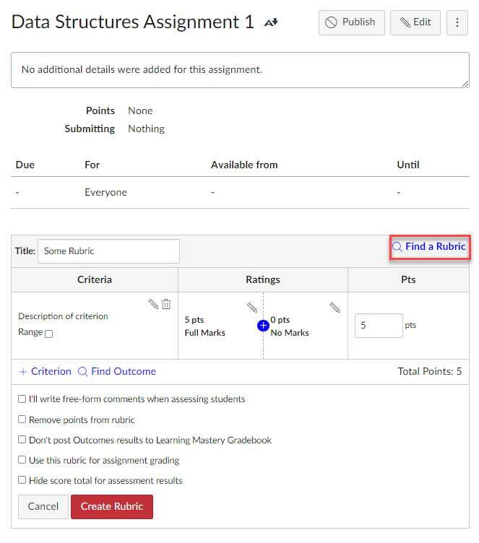
- Scroll to find and click the course under Find a Rubric in the left column.
- Click the specific rubric in the middle column.
- Click Use This Rubric in the right column.
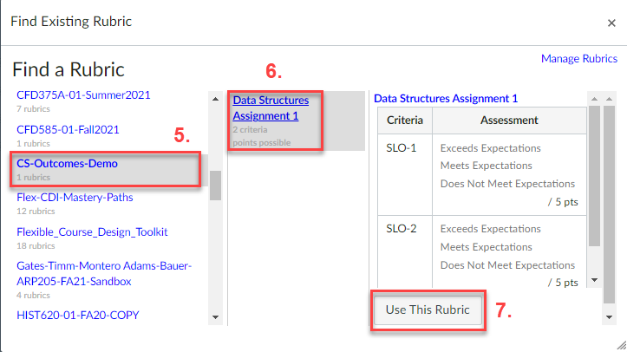

- To get to the rubric settings, click the pencil icon. Click the magnifying glass icon to find another rubric, or the trash can icon to delete the rubric.
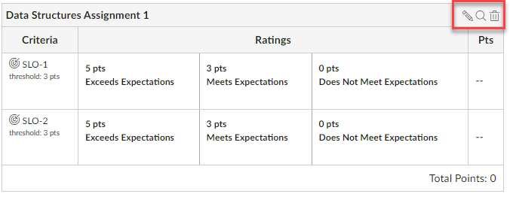

- Select the desired settings as described below and click Update Rubric.
[1] Do not select “I’ll write free-form comments when assessing students” as outcomes do not work with this option.
[2] Select “Remove points from rubric” if you do not wish for any of the rubric points to show up for the students. Even if selected, the points will still appear in the Outcome Results report.
[3] If “Don’t post Outcomes results to Learning Mastery Gradebook” is selected, students will still be able to see rubric and outcome results in their Grades view and submission details pages but results will not be posted to the Learning Mastery Gradebook.
[4] Select “Use this rubric for assignment grading” if you want the rubric points to go to the Gradebook. Outcomes will still get reported even if you do not select this option as long as you select the outcome ratings for each student.
[5] Select “Hide score total for assessment results” if you don't want students to see the score total for the rubric. Students can still see the point values for each criterion, but the total score will not be shown at the bottom of the rubric. This option is only available if the rubric is not being used for grading, so you won’t see this option once you select option 4.

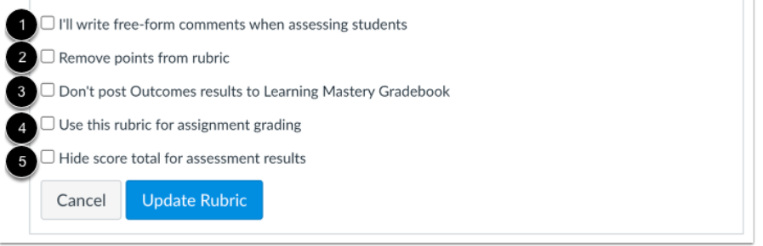

IV. Use the rubric to score the assignment
- In the desired course, go to the assignment either in Assignments or Modules.
- Click the assignment link.
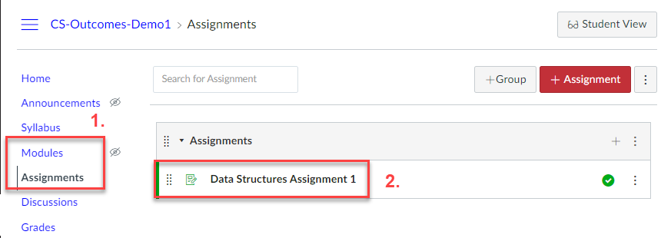
- Click Speedgrader.
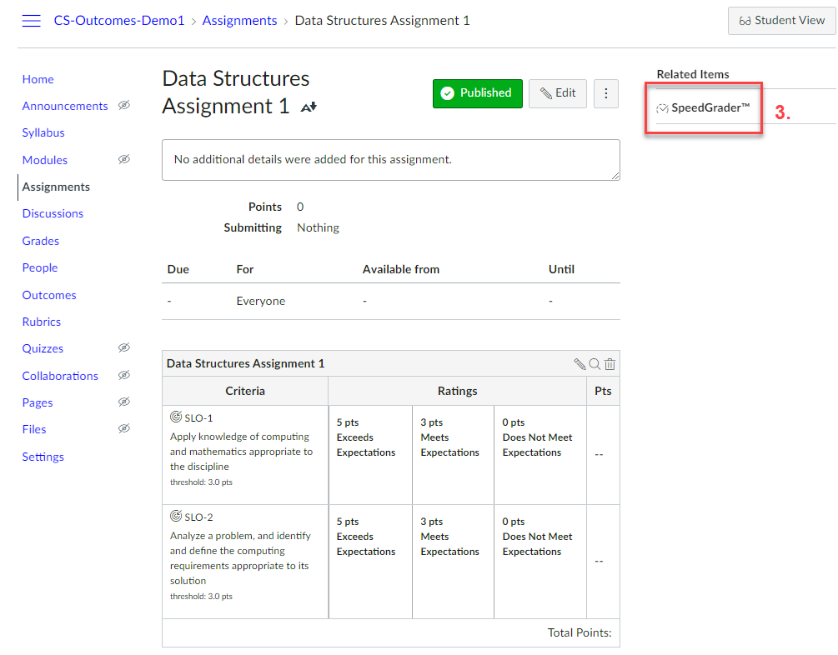

- Click the drop-down menu to select a student.
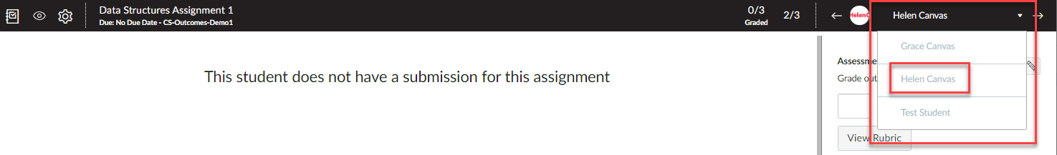
- Click View Rubric.To resize or expand the rubric, click and drag the area by the 3 dots.
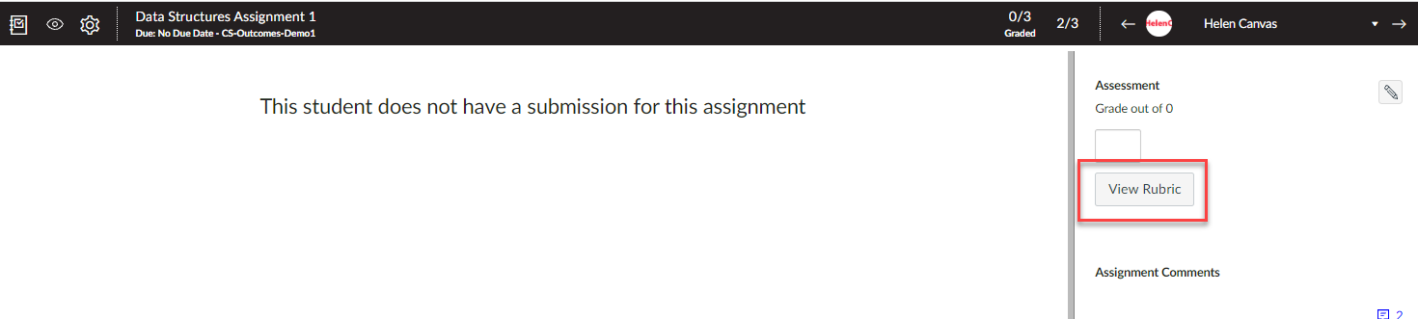
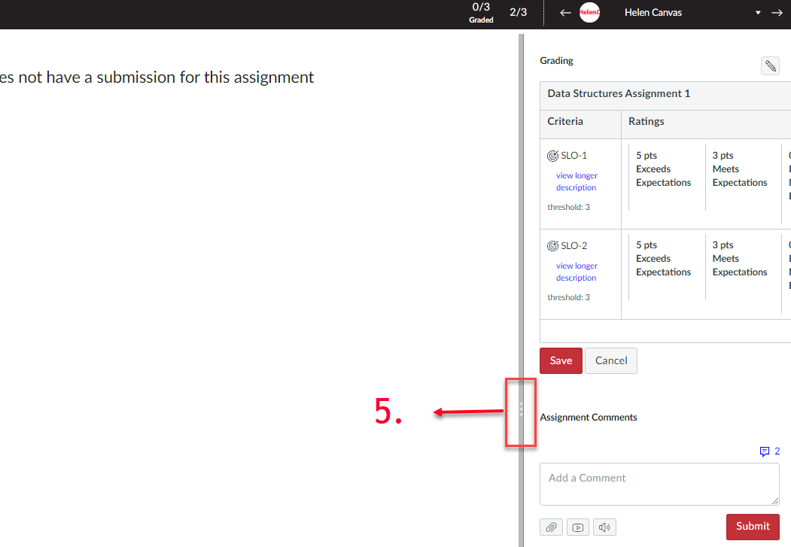

6. Click view longer description to see the outcome details.
7. Click to select the rating.
8. Click the comment bubble to leave any comments (optional).
9. Click Save to finalize the scoring.
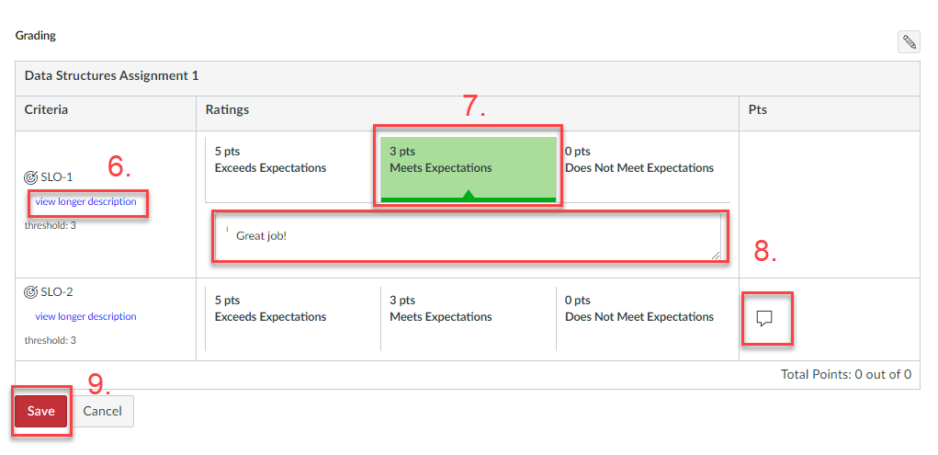
10. Click the drop-down menu or the arrow next to it to move to the next student.
11. Repeat steps 5-10 to finish scoring all students.

