Academic Review Guidelines San Diego State University

**Purpose**: The San Diego State University Academic Review (AR) Process will provide each academic unit with the opportunity to examine its strengths, areas for improvement, and strategic goals in a systematic way. The Academic Review process allows us to:

1. Guide the future direction and priorities for the programs and the institution
2. Support the continuous improvement of the program by identifying areas for improvement and development
3. Promote dialogue within the department as well as across departments fulfill accreditation and state requirements
4. Assure institutional quality to students, faculty, parents, alumni, and other stakeholders
5. Provide an opportunity for a structured dialogue between the department and the administration

In essence, ARs are an opportunity for academic units to reflect on their accomplishments, challenges, and opportunities to address such questions as: *How well are we preparing all our students to meet and exceed the challenges they will experience upon graduation? How well are we supporting faculty and staff in the integration of their teaching, research, scholarship, and creative endeavors, and service? How well are we equipped to meet the emerging challenges and demands of our disciplines and their respective roles in our broader society?*

While meaningful and regular ARs are an explicit requirement of the California State University system and its Board of Trustees as well as for continued accreditation through the WASC Senior College and University Commission (WSCUC), these guidelines are written in a manner that will affirm faculty’s ability to focus on what they care about while providing evidence that can inform program, unit, and college-level decision-making.

The intended outcome of each AR is the collaborative development of an Action Plan among Academic Affairs, the College Dean, and the academic unit that will address identified challenges and opportunities for improvement, primarily with existing resources and secondarily on additional strategic investments.

# Overview of the Academic Review Process

1. **Notification:** Deans will be notified at least one semester ahead of the semester of their Academic Review (AR). Chairs/Directors whose programs are undergoing AR will be provided with these Guidelines and are encouraged to develop any additional desirable review components that they deem appropriate. Department Chairs/Directors with questions regarding the Academic Review process may contact the Associate Vice President for Curriculum, Assessment and Accreditation Madhavi McCall [(mccall@sdsu.edu,](mailto:(mccall@sdsu.edu) 619-594-5050).

NOTE: Professionally accredited programs may propose a modified approach to their AR that leverages existing efforts and reduces redundancies, while still meeting the spirit and intent of the process with respect to institutional priorities. Please contact Associate Vice President for Curriculum, Assessment and Accreditation Madhavi McCall [(mccall@sdsu.edu,](mailto:(mccall@sdsu.edu) 619-594-5050) for procedures.

1. **Selection of Site Visit Dates and potential Review Team Members:** Chairs/Directors should identify at least five preferred two-day Site Visit blocks (Monday/Tuesday or Thursday/Friday) during the scheduled review semester that will maximize participation of their faculty, students, and staff. Any blocks that are particularly problematic (e.g., dates of discipline-focused national meetings, etc.) should also be identified. These preferred and to-be-avoided dates should be provided to Joseph Baker [(jbaker4@sdsu.edu),](mailto:(jbaker4@sdsu.edu) by the deadline indicated on the initial notification.

The typical Review Team comprises two external members from aspirational academic programs and one internal SDSU faculty member from outside the program’s college. This composition may be modified with approval of the Academic Affairs leadership team. Academic units shall submit Review Team nominations to Joseph Baker [(jbaker4@sdsu.edu)](mailto:(jbaker4@sdsu.edu) by the deadline indicated in the initial notification.

***External Reviewers:*** The Chair/Director shall submit a list of no fewer than eight external faculty from aspirational academic programs whom they consider well-qualified to serve as reviewers.

***Internal Reviewers:*** The Chair/Director shall also submit the names of four tenured SDSU faculty members with appointments outside the college whom they consider well-qualified to serve on the Review Team.

Each nomination should include an email address. Nominated reviewers may not have close professional or personal relationships with faculty in the unit undergoing review; any potential conflicts of interest must be declared and discussed with the Dean’s office prior to their nomination.

1. **Finalize Dates and Review Team:** As soon as possible after receiving potential dates and names of reviewers, the AVP-CAA will finalize the dates of the unit’s academic review and the names of the review team. Review team members will be invited to participate by an email from either the AVP-CAA or the College Dean, depending on the College’s preferred practice. The AVP-CAA will work with the Provost Office to secure Academic Affairs Leadership Team participation for the site visit.
2. **Production of the AR Documents:** The Self-Study is the centerpiece of the AR process, enabling programs to develop a deliberate and inclusive approach to its development. The Self-Study (1) provides context for the academic unit’s mission, activities, ambitions, and priorities, (2) highlights recent

achievements and progress, and (3) establishes future directions, opportunities, and challenges. This document provides a first impression of the academic unit to the Review Team, so it should be carefully developed and edited to provide a cohesive narrative with consistent voice, formatting, etc. The Site Visit Schedule may include sessions with faculty, staff, and students as appropriate, with at least two hours scheduled as private work sessions for the Review Team.

Templates for the Self-Study and the Site Visit Schedule are appended to these Guidelines. The Chair/Director shall provide final drafts of the Self-Study and Site Visit Schedule as Word files to their Dean’s office at least seven weeks prior to the Site Visit. These materials will be reviewed by the Dean’s office for completeness and any comments/suggestions/requests for revision shall be provided back to the Chair/Director within one week.

1. **Distribution of Finalized AR Documents**: Following Dean’s office approval of the Self-Study and Site Visit Schedule and at least four weeks prior to the Site Visit, the academic unit shall provide Word and pdf versions of the Self-Study and pdf version of any documents referred to in the Self-Study to Joseph Baker [(jbaker4@sdsu.edu),](mailto:(jbaker4@sdsu.edu) who will share all finalized AR materials with relative parties across the campus and with members of the Review Team.
2. **Schedule and Conduct of the Site Visit:** The Site Visit is typically two days, beginning and ending with sessions between the Review Team and members of the Academic Affairs leadership team (i.e., Provost, Graduate Dean, and AVP Faculty Advancement and Student Success, AVP Curriculum, Assessment, and Accreditation, College Dean and Associate Dean(s)). Members of the unit are responsible for transporting out-of-town Review Team members to and from SDSU and other locations as well as planning and funding lunches and dinners. Hotel accommodations, travel reimbursements, and honoraria are arranged and covered by Academic Affairs.
3. **Production and Dissemination of the Review Team Report:** The Review Team will prepare an AR Report that represents their collective view of the strengths and weaknesses in each area of the Self-Study as well as recommendations regarding current and future opportunities and challenges. The Review Team shall submit its AR Report electronically within six weeks of the completion of the Site Visit, whereupon it will be provided to the Academic Affairs leadership team, the College Dean’s office, and the Chair/Director of the academic unit.
4. **Response to Review Team Report:** The Chair/Director of the academic unit may submit a written response to the AR Report within four weeks of receipt. The response may address each of the major findings and recommendations of the report as well as additional information.
5. **Action Plan and Capstone Meeting:** The Capstone Meeting between the academic unit’s Chair/Director, the Dean, and the Academic Affairs leadership team will be scheduled as soon as possible upon receiving the response to the Review Team report. The outcomes of this meeting will be summarized by the Dean in the form of a draft Action Plan for finalization and endorsement by the Dean, Academic Affairs leadership team, and Chair/Director as a representative for the academic unit. The Dean will be responsible for scheduling any follow-up meetings regarding progress on this Action Plan.

**Summary: San Diego State University Academic Review Timeline**

| **Stage** | **Component** | **Deadline** | **Specific Date** |
| --- | --- | --- | --- |
| 1 | AVP-CAA notifies College deans, Chairs/Directors  of upcoming AR and provides AR Guidelines | At least one semester prior to semester of AR |  |
| 2 | Chair/Director submits lists of  five viable Site Visit dates and potential Review Team members (8 external reviewers and 4 internal reviewers) to AVP-CAA | Four weeks after chair is notified of upcoming AR |  |
| 3 | AVP-CAA invites reviewers, finalizes review team members and review dates | AVP-CAA works on this immediately following submission of names and dates by Department |  |
| 4 | Chair/Director submits final drafts of Self-Study and Site Visit Schedule to Dean’s office  Dean or Dean’s representative reviews self-study and provides feedback to Chair/Director | Chair/Director submits draft at least seven weeks  prior to Site Visit |  |
| 5 | Dean approves Self-Study and all supporting materials.  Dean or Dean’s representative uploads self-study and material to shared drive.  AVP-CAA shares material with Reviewers and Academic Affairs leadership team | Dean or Dean’s representative uploads material at least four weeks prior to Site Visit  AVP-CAA shares immediately upon receipt |  |
| 6 | **Site Visit** | |  |
| 7 | Review Team’s Report submitted to AVP-CAA.  AVP-CAA distributes to Academic Affairs Leadership Team, College Dean’s Office, and Chair/Director of academic unit | Six-eight weeks after  completion of Site Visit |  |
| 8 | Academic unit submits written response to Review Team Report to AVP-CAA | Four weeks after  receipt of Review Team Report |  |
| 9 | Dean meets with department to discuss review and response | Within 1 month of academic unit response |  |
| 10 | Academic units work with their Dean’s office to develop an Action Plan based on the review and response that will be discussed at the capstone meeting. | Dean’s office and department chair should jointly develop on action plan within 2 months of academic unit response |  |
| 11 | Action plan sent to AVP-CAA by Dean or Dean’s representative. | As soon as constructed |  |
| 12 | Capstone Meeting with Dean, Chair/Director, and Academic Affairs leadership team. | As soon as possible |  |

*The Site Visit Schedule below is provided as a REPRESENTATIVE SAMPLE; academic unit should develop their own schedule as appropriate.*

*Timing of Entrance Meeting with Academic Affairs Leadership Team should not be modified unless previously approved.*

# Department of <Name> Academic Review Site Visit Schedule for Day One – <Date>

|  |  |  |
| --- | --- | --- |
| **Time** | **Component** | **Location** |
| TBD | Transport from Hotel | Hotel Lobby |
| 9:00 – 9:30 | Entrance Meeting with  Academic Affairs Leadership Team |  |
| 9:30 – 10:00 | Pickup by Chair/Director and Break |  |
| 10:00 – 10:30 | Chair/Director (<Name>) |  |
| 10:30 – 11:30 | Department Executive Committee |  |
| 11:30 – 1:00 | Lunch with Executive Committee |  |
| 1:00 – 2:00 | Faculty Group 1 (<Names>) |  |
| 2:00 – 3:00 | Program Assessment Coordinator |  |
| 3:00 – 3:30 | Break |  |
| 3:30 – 4:00 | Program Staff (<Names>) |  |
| 4:00 – 5:00 | Review Team Work Session |  |
| 5:00 – 7:00 | Social Event and Dinner |  |
| 7:30 | Transport from dinner to hotel |  |

*<The Site Visit Schedule below is provided as a REPRESENTATIVE SAMPLE; academic unit should develop their own schedule as appropriate.>*

*<Timing of Exit Meeting with Academic Affairs Leadership Team should not be modified unless previously approved.>*

**Department of <Name> Academic Review Site Visit Schedule for Day Two – <Date>**

|  |  |  |
| --- | --- | --- |
| **Time** | **Component** | **Location** |
| TBD | Transport from Hotel to SDSU by <Name> | Hotel Lobby |
| 8:30 – 9:30 | Review Team Work Session |  |
| 9:30 – 10:00 | Meeting with Undergraduate and Graduate Advisers (<Names>) |  |
| 10:00 – 10:30 | Faculty Group 2 (<Names>) |  |
| 10:30 – 11:30 | Students |  |
| 11:30 – 1:00 | Review Team Working Lunch |  |
| 1:00 – 2:15 | Chair/Director and Other Individuals as Requested |  |
| 2:15 – 3:00 | Break and Escort <Name> |  |
| 3:00 – 3:30 | Exit Meeting with Academic Affairs Leadership Team |  |
| 3:30 | Transport to airport (if needed) by <Name> |  |

Self-Study for the Academic Review of

<Program Title> at San Diego State University

<Dates of Academic Review>

Prepared by:

< Name, Title and/or Role within Unit, Unit Name>

< Name, Title and/or Role within Unit, Unit Name>

< Name, Title and/or Role within Unit, Unit Name>

< Name, Title and/or Role within Unit, Unit Name>

< Name, Title and/or Role within Unit, Unit Name>

Internally Reviewed and Approved by the College of <XXX>

on [Insert Date]

Provided to the Academic Review Team:

<External Reviewer #1, Program, Institution>

<External Reviewer #2, Program, Institution>

<Internal Reviewer, Program, Institution>

Academic Program Review Self-Assessment Guidelines

# Instructions

The self-assessment reports on six areas: the overall goals, trends, and challenges; response to prior academic reviews; the academic/student experience for major or graduate students; research; the human, physical and financial; the guiding principles, relating to success for all students and shared governance; and conclusion.

# Overall goals, trends, and challenges

The purpose of this section is to provide the department an opportunity to tell the reviewers about the program, its goals, and its challenges as well as to reflect on the trends in the discipline. These questions serve as guidance in this area.

* 1. What sets this department apart from other departments within the discipline and within the university?
  2. What is the vision and mission of the department? What are the department’s goals and aspirations? How can the college and the university help support those goals and aspirations?
  3. Who are your benchmark peers and in which areas are you stronger and weaker? How has this changed over time?
  4. What are the key challenges that face the department? How can the college and the university help mitigate those challenges?

1. **Response to Previous Academic Review** (i.e., review team report, program response letter, and institutional summary letter; include these in the appendices).
   1. Describe the unit’s response to major issues, challenges, and recommendations identified through the previous academic review.
   2. Summarize the effects of these actions, and how they influence the current work and priorities of the unit.

# Academic/ Student Experience

A central role in the academic department is to support students’ academic experiences, and this section involves reporting on the quality of those experiences by looking at enrollment, learning objectives, and learning outcomes of the students in the department’s programs.

* 1. What are the enrollment trends in your programs? Please include student demographic analysis.
  2. Have your programs undergone any major curriculum changes since the last review and if so, why were these changes implemented?
  3. How do you access the success of your degree learning objectives? Please provide your degree learning objectives, a curriculum map, and updated assessment results for your degree learning outcomes. A report downloaded from Nuventive will be sufficient.
  4. What significant undergraduate and graduate initiatives that are either underway or planned to promote student success?
  5. To what degree are students successfully placed upon graduation?

# Research and Creative Activities

One of an academic department’s main missions is to produce research and creative activities, and this section of the report asks the department to reflect on its productivity and impact in these areas.

* 1. How would you gauge the success of the research mission for the department? How does your department’s research productivity compared to that of peer departments?
  2. How do you anticipate your department supporting the R1 institutional goals?
  3. Are there opportunities for undergraduate and graduate student research? If so, please describe how student research is supported.
  4. How can the college or the university support the research mission of the unit?

# Resources

Understanding the resources of a department provides a useful way to review opportunities for growth.

* 1. Given the department’s goals and objectives, what would be the department’s next request for a faculty line and why?
  2. Given the department’s goals and objectives, what are the department’s staffing and advising needs beyond what is currently available and why?
  3. Given the department’s goals and objectives, where might development activities be most useful?
  4. Given your department’s goals and objectives, where are resources for teaching and student success most needed?
  5. To what extent is research and teaching space a problem for the department? Have the research and teaching space needs changed since the last academic review and if so, how have

those changes been addressed (it is fair to note that the changes have not been adequately addressed).

* 1. What engagement activities does your department perform? Include service to the profession (e.g. officers in national academic organizations, advisory board memberships, conferences organized, editorships of major journals) and to broader social objectives.

# Guiding Principles: Success for All Students and Shared Governance

The success of a department can be measured in several ways, but few underlying principles

capture the vibrancy of a department more than how the department addresses the success of students, and shared governance. The following questions are meant to all for reflection on

these important principles.

* 1. How does the department illustrate its commitment to success for all students through its vision, leadership, messaging, incentives? What specific progress has been made on goals and strategies to impact student success (if applicable)?
  2. How does department decision-making processes ensure appropriate consultation and shared responsibility for collective judgments about matters of unit policy and procedure? How have these proven successful and where might they benefit from improvement?
  3. How are the unit’s bylaws shared, discussed, and modified within the unit?

# Conclusions

* 1. Considering the findings of this Self-Study, please describe the department’s specific areas of distinction and some specific areas for improvement.
  2. How can the college and university help with the areas of improvement through existing resources or additional strategic investments?

1. Appendices: Include the following appendices and refer to information within these appendices as appropriate within the body of the Self-Study. Academic units may include additional relevant appendices as appropriate and referenced within the Self-Study.

Appendix 1. Review Team report from previous Academic Reviews, Unit’s formal written response to the previous Review Team report, and Action Plan from previous review (if produced).

Appendix 2. Catalog description of all programs within the unit.

Appendix 3. List of all faculty that includes faculty rank and years of service.

Data to be provided by Curriculum, Assessment, and Accreditation



**Data Points from ASIR**

* Department FTES over time
  + ASIR Link: https://asir.sdsu.edu/course-ftes-data/ftes-by-department-discipline/
  + Excel, example:



* Enrollment by Primary Major (displays gender, can also do second major)
  + ASIR Link: https://asir.sdsu.edu/enrollment-data/enrollment-major-summary- data-table/
  + Excel, example:
* Enrollment by Ethnicity (both undergrad and grad, displayed separately)
  + ASIR Link: https://tableau.sdsu.edu/#/views/TotalStudentEnrollment_0/EnrollmentbyEthnicity

?:iid=6

* + PDF, example:

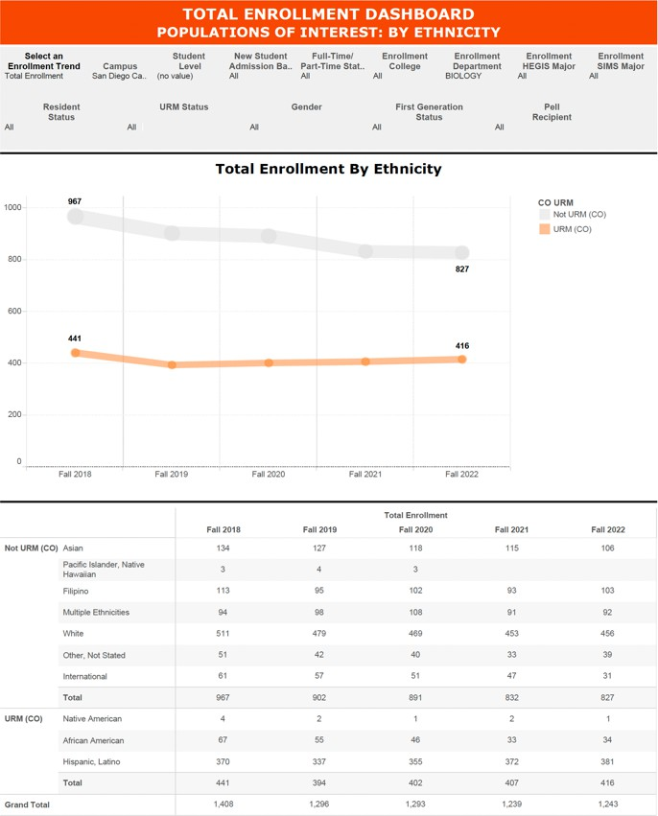

* Faculty Headcounts by Gender
  + ASIR Link: https://tableau.sdsu.edu/#/views/Headcounts/FacultybyDeptGender?:iid=8
  + Excel, example:



* Faculty headcounts by Ethnicity
  + ASIR Link: https://tableau.sdsu.edu/#/views/Headcounts/FacultybyDeptEthnicity?:iid=1
  + 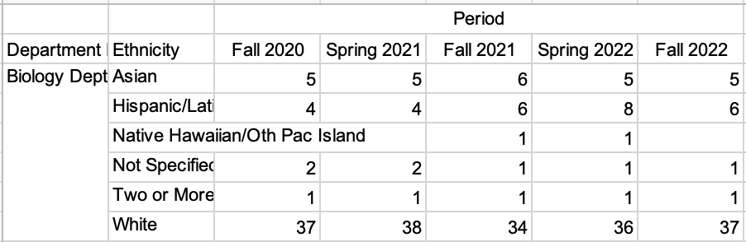Excel, example:
* Graduation Rates (can do by Gender and Ethnicity)
  + ASIR Link: https://tableau.sdsu.edu/#/views/GraduationRates/GraduationRatesByEthnicity?:i id=1
  + PDF, example:

